Notice of intention to vacate by SDA resident
Residential Tenancies Act 1997, Part 12A
Specialist Disability Accommodation Section 498ZZA
Note:
Use this form if you are a specialist disability accommodation (SDA) resident to issue a notice of intention to vacate to the SDA provider (the provider).
Enter text in spaces provided only.
Give this form to the SDA provider.
This document is available for download at consumer.vic.gov.au/forms.

How to use this form

Complete all parts of the form.

Sign the form.

Send a completed copy of the form to your SDA provider.

How to serve this notice
You can give this notice by post, or deliver it personally to the provider between 8am and 6pm, or email it (with consent).
You can only give this notice by email if you already have the provider’s written consent to receive notices and other documents this way.
You and the provider may have consented to electronic service of notices and other documents in the SDA residency agreement.

Telephone Interpreter Service
If you have difficulty understanding English, contact the Translating and Interpreting Service (TIS) on 131 450 (for the cost of a local call) and ask to be put through to an Information Officer at Consumer Affairs Victoria on
1300 55 81 81.
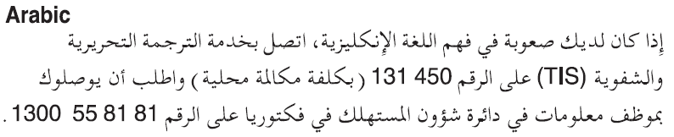
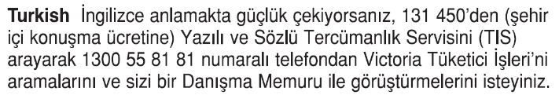
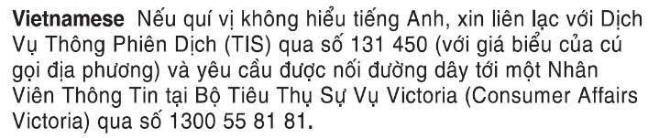

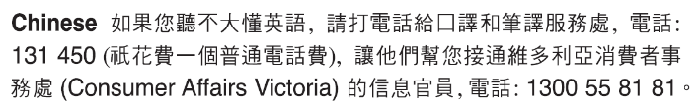
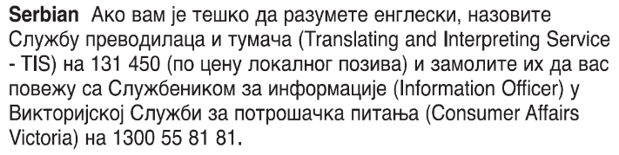



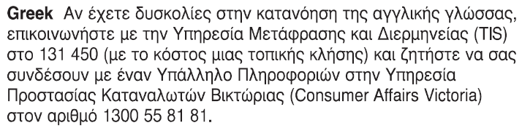
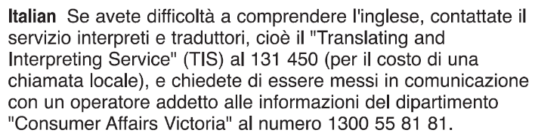 Information about renting is available in other languages at consumer.vic.gov.au/languages.

Notice of intention to vacate

by SDA resident SDA resident’s copy
Residential Tenancies Act 1997 S498ZZA

SDA provider details
- This notice is given to:
(SDA provider’s name)
SDA provider’s address:
(can be an agent’s address)

SDA resident details
SDA resident’s name:
This notice is given on behalf of the resident by the SDA resident’s guardian or administrator:
(if applicable, write name below)
Regarding the SDA dwelling at:
(write address)
Address for serving documents:
(if the same as in 5, write ‘as above’)
- SDA resident’s contact telephone numbers:
Business hours:
After hours:

Service details
- This notice is given:
(mark one method only and if posted, note the delivery speed)
By hand:
By registered post:
By ordinary post:
By email:
Insert email address:
(if applicable)
On:  (dd/mm/yyyy) | / /
I intend to vacate the SDA on:
Date:  (dd/mm/yyyy) | / /

Within 24 hours of receiving this notice the SDA provider must send a copy of this notice to:
the NDIA CEO (if this notice has been given to you by a resident who is an NDIS participant), and
the SDA resident’s guardian or administrator (if this notice has been given to you by the resident), and
the Director of Consumer Affairs Victoria. To notify us, visit consumer.vic.gov.au/SDAnotify.

Signature of SDA resident:
(or guardian or administrator if applicable)

Notice of intention to vacate

by SDA resident SDA resident support person’s copy
Residential Tenancies Act 1997 S498ZZA

SDA provider details
- This notice is given to:
(SDA provider’s name)
SDA provider’s address:
(can be an agent’s address)

SDA resident details
SDA resident’s name:
This notice is given on behalf of the resident by the SDA resident’s guardian or administrator:
(if applicable, write name below)
Regarding the SDA dwelling at:
(write address)
Address for serving documents:
(if the same as in 5, write ‘as above’)
- SDA resident’s contact telephone numbers:
Business hours:
After hours:

Service details
- This notice is given:
(mark one method only and if posted, note the delivery speed)
By hand:
By registered post:
By ordinary post:
By email:
Insert email address:
(if applicable)
On:  (dd/mm/yyyy) | / /
I intend to vacate the SDA on:
Date:  (dd/mm/yyyy) | / /

Within 24 hours of receiving this notice the SDA provider must notify:
the NDIA CEO (if this notice has been given to you by a resident who is an NDIS participant), and
the SDA resident’s guardian or administrator (if this notice has been given to you by the resident), and
the Director of Consumer Affairs Victoria. To notify us, visit consumer.vic.gov.au/SDAnotify.

Signature of SDA resident
(or guardian or administrator if applicable):

Notice of intention to vacate

by SDA resident SDA provider’s copy
Residential Tenancies Act 1997 S498ZZA

SDA provider details
- This notice is given to:
(SDA provider’s name)
SDA provider’s address:
(can be an agent’s address)

SDA resident details
SDA resident’s name:
This notice is given on behalf of the resident by the SDA resident’s guardian or administrator:
(if applicable, write name below)
Regarding the SDA dwelling at:
(write address)
Address for serving documents:
(if the same as in 5, write ‘as above’)
- SDA resident’s contact telephone numbers:
Business hours:
After hours:

Service details
- This notice is given:
(mark one method only and if posted, note the delivery speed)
By hand:
By registered post:
By ordinary post:
By email:
Insert email address:
(if applicable)
On:  (dd/mm/yyyy) | / /
I intend to vacate the SDA on:
Date:  (dd/mm/yyyy) | / /
Signature of SDA resident:
(or guardian or administrator if applicable)

Information for Providers.
Should you be issued this form for 498ZZA Intention to vacate, within 24 hours of receiving this notice you (the SDA provider) must give a copy of this notice to:
The NDIA CEO (if this notice has been given to you by a resident who is an NDIS participant, and
The SDA resident’s guardian or administrator (if this notice has been given to you by the resident), and

The Director of Consumer Affairs Victoria. To notify us, visit consumer.vic.gov.au/SDAnotify.

After receiving this notice, Consumer Affairs Victoria will provide a copy of the notice to the Public Advocate. For SDA residents who are funded by the Transport Accident Commission or the Victorian WorkCover Authority, Consumer Affairs Victoria will also send them a copy of the notice.

